**POWER BI PROJECT**

**Task 1:**

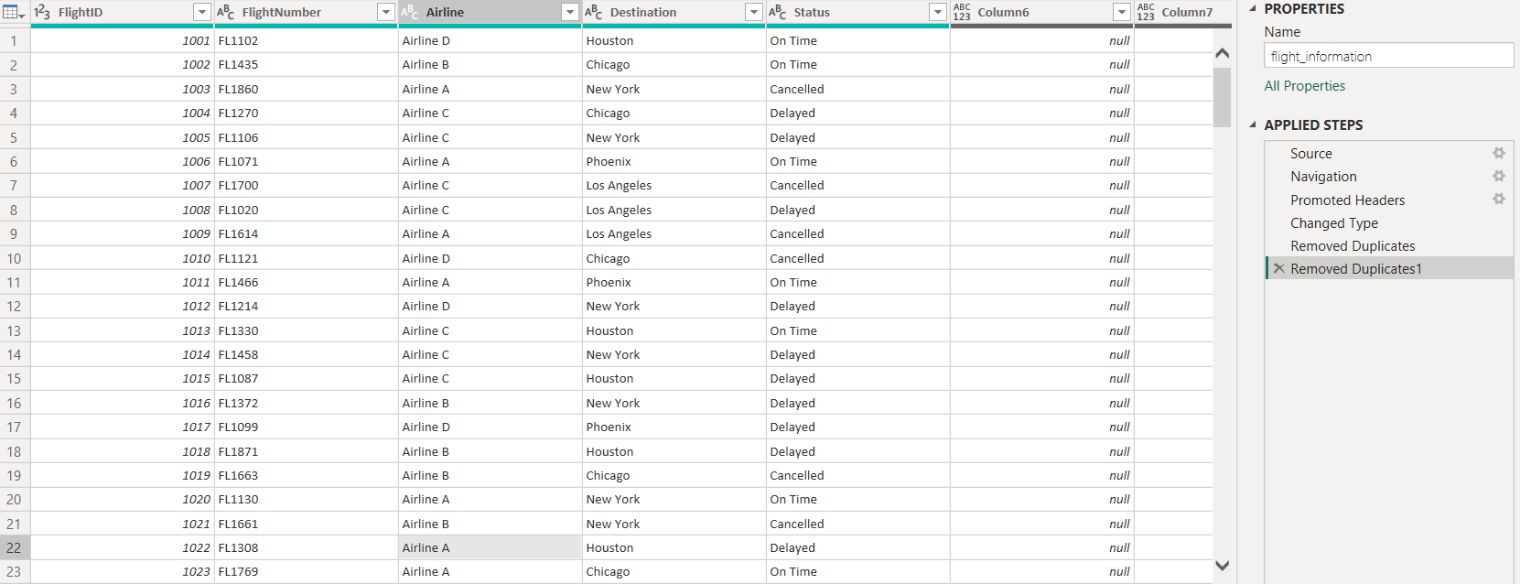

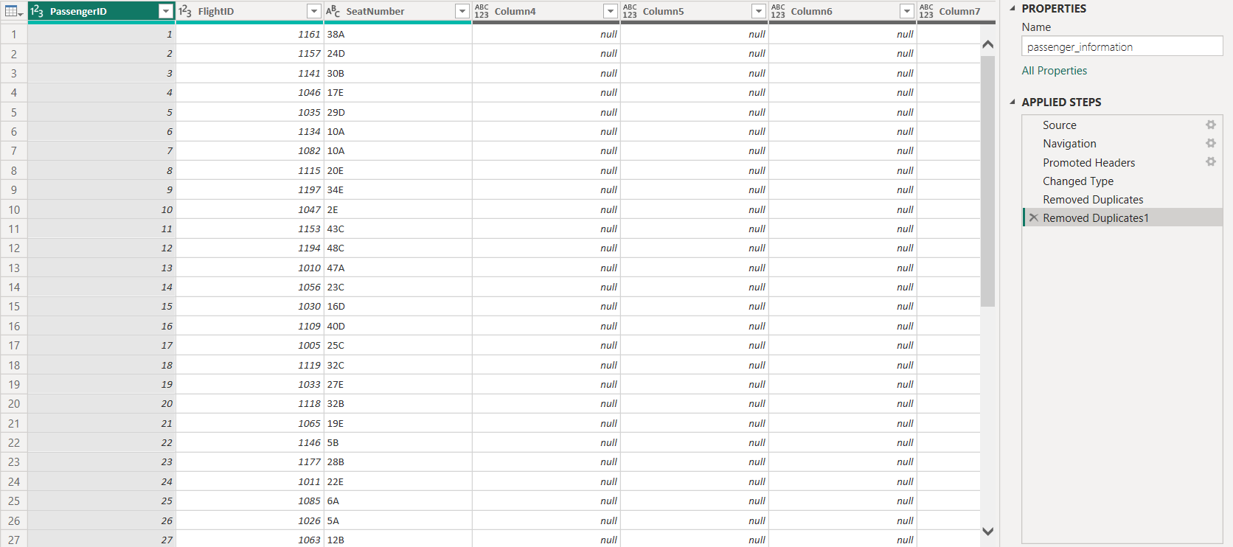

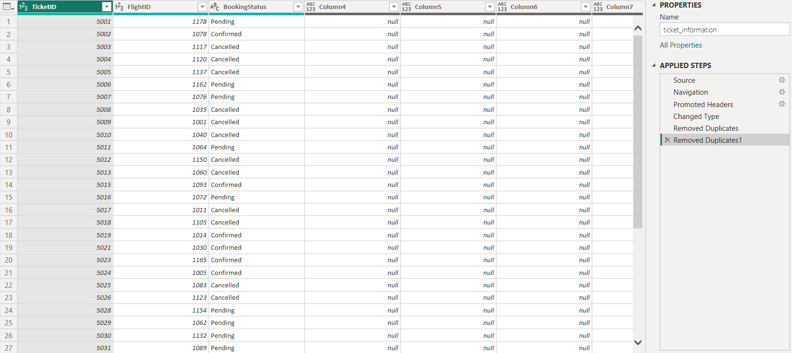

* The above pictures shows 3 different datasets of the project(flight information, ticket information and passenger information).
* At first we need to use dropdown arrow to confirm if is there any blank or missing values.
* Then select the ID column or reference column and remove duplicates.
* Check the data types of each column, if its not suited choose accordingly.

**Task 2:**

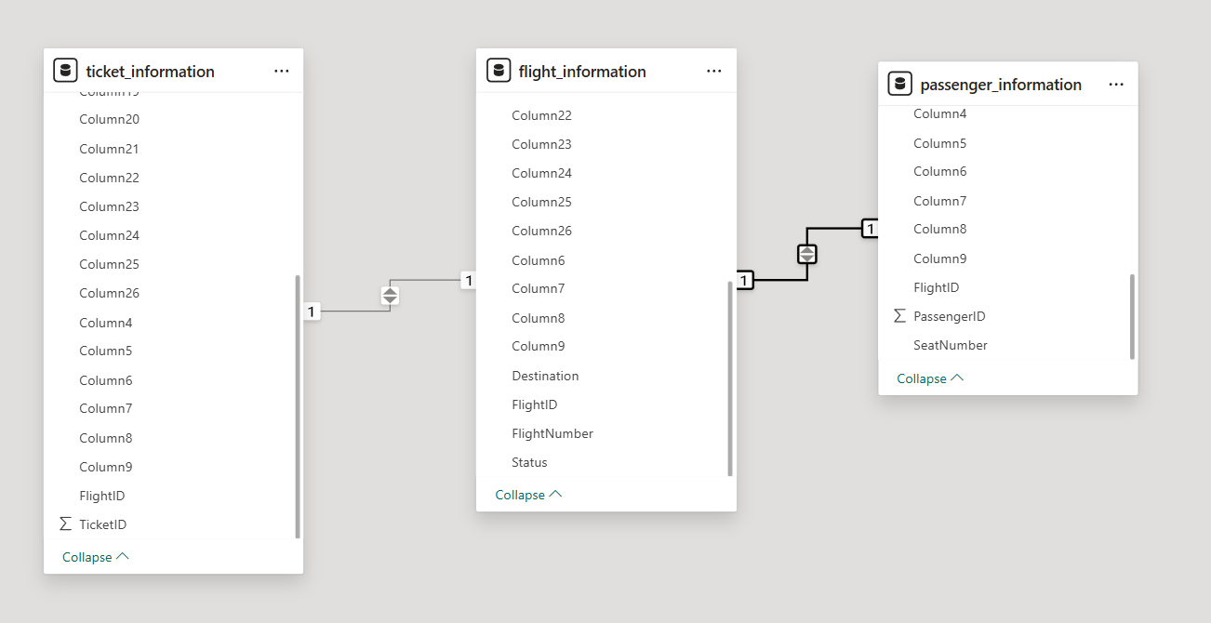

* Go to model view after transform the data—Key (Flight ID)
* Since it has different ID’s across each data set the cardinality would be 1:*(one to many)

**Task 3:**

**Conditional column:**

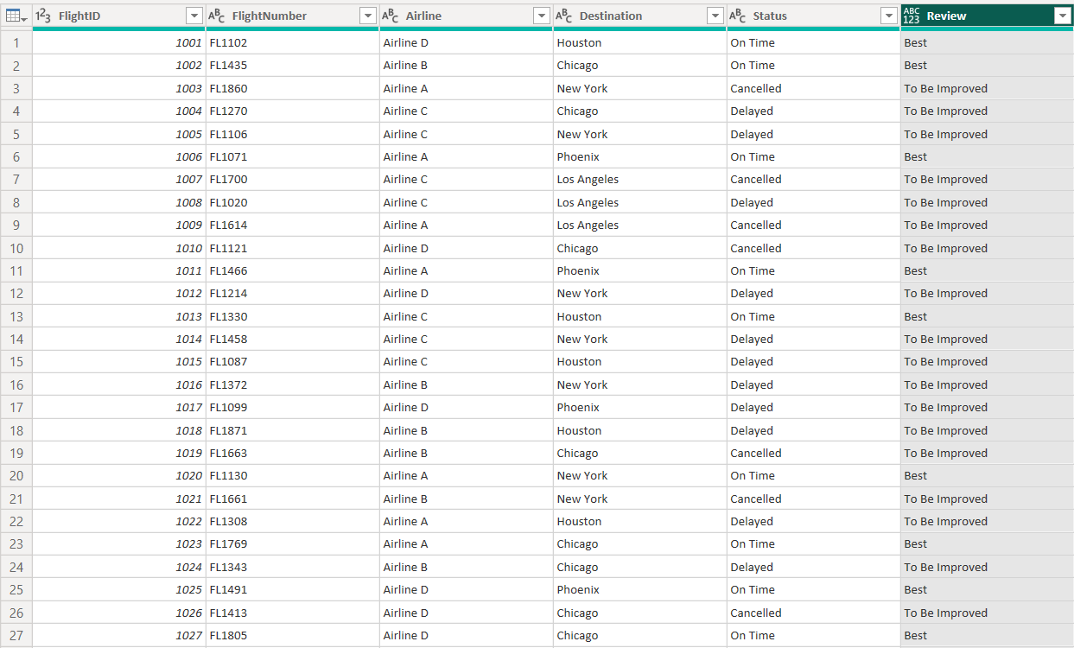

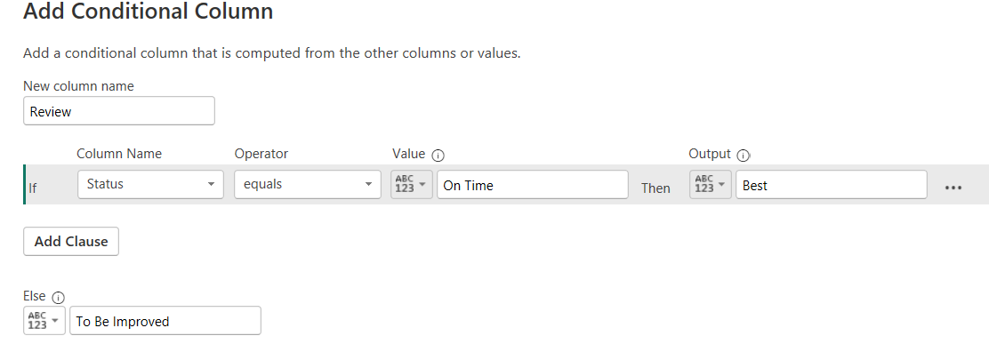

* Go to transform—flight_information dataset—go to column—select conditional column—name the column Review—column name(Status)—operator(equals)—value(On Time) and output(best)—else (to be improved)

**Column from Examples:**

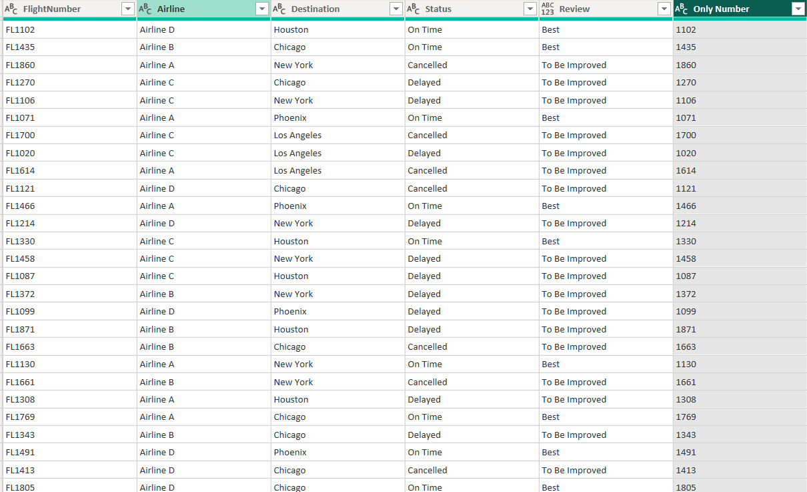

* Go to transform data – add column—column from examples—selection—select the FlightNumber column—In new column write 2 or 3 sample examples—then enter—change the column name to Only Number.

**Task 4:**

**Total passenger:**

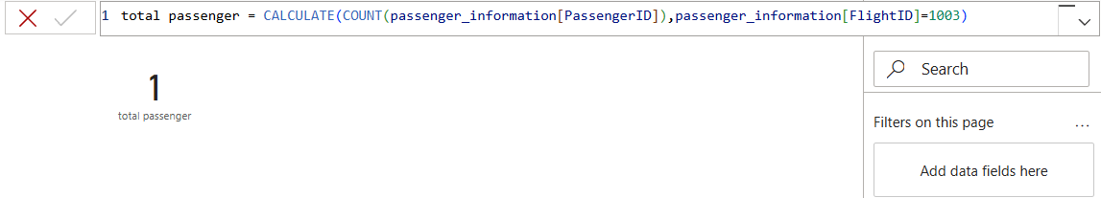

* Go to modeling—new measure—add the above formula and specify the flight number for specified flight information—name it has total passenger.

**Total tickets booked:**

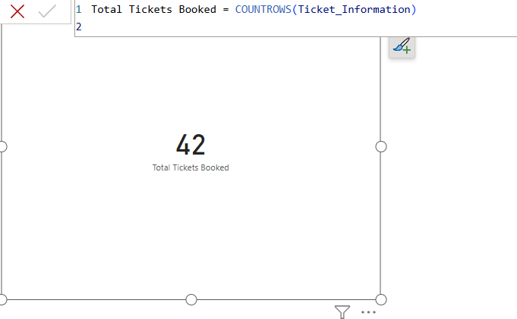

* Go to modeling—new measure—add the above formula to get filtered total tickets—and the column has Total Tickets Booked.

**Best flights:**

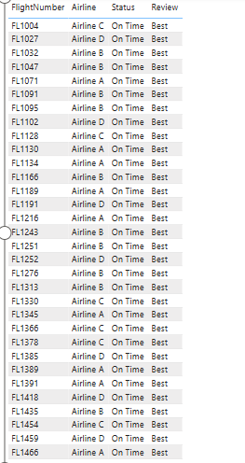

* Go to Table on build—use flight information datasets—add flightNumber, Airline, Status and Review—then go to filter pane—under review select only Best.

**Task 5:**

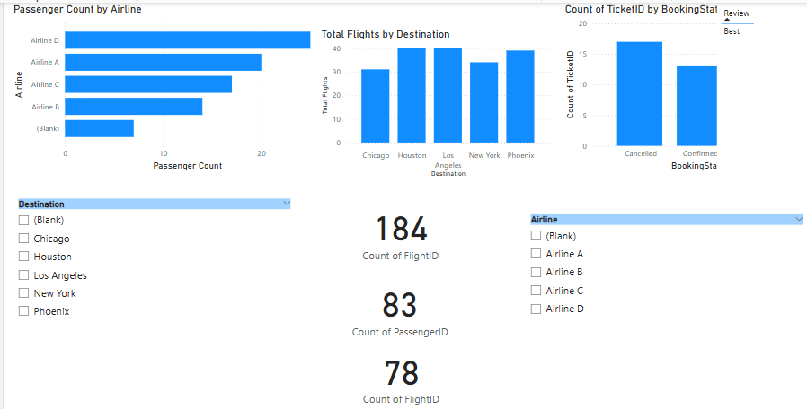

**Passenger Count by Airline**

* Create measure-- Passenger Count = COUNTROWS(passenger_information)—Insert bar chart—add Airline and Passenger Count

**Ticket booking status**

* Use ticket information table—insert bar chart—add booking status and TicketID and set it to count.

**Flights by airline and destination**

* Create measure—total flight = COUNTROWS(Flight_Information)-- Add stacked column chart—add Airline, destination and total flights.

**Add interactive features:**

**Destination and Airline**

* Select slicers – add Destination
* Select slicers—add Airline.

**Quick views**

* For total flights—select card visuals – add flightID from flight_information.
* For total passenger – select card visuals—add passengerID from passenger_information.
* For best flight—select card visuals—add flightID from flight_information and add flight category to filter and select only best.

Airline-specific pages

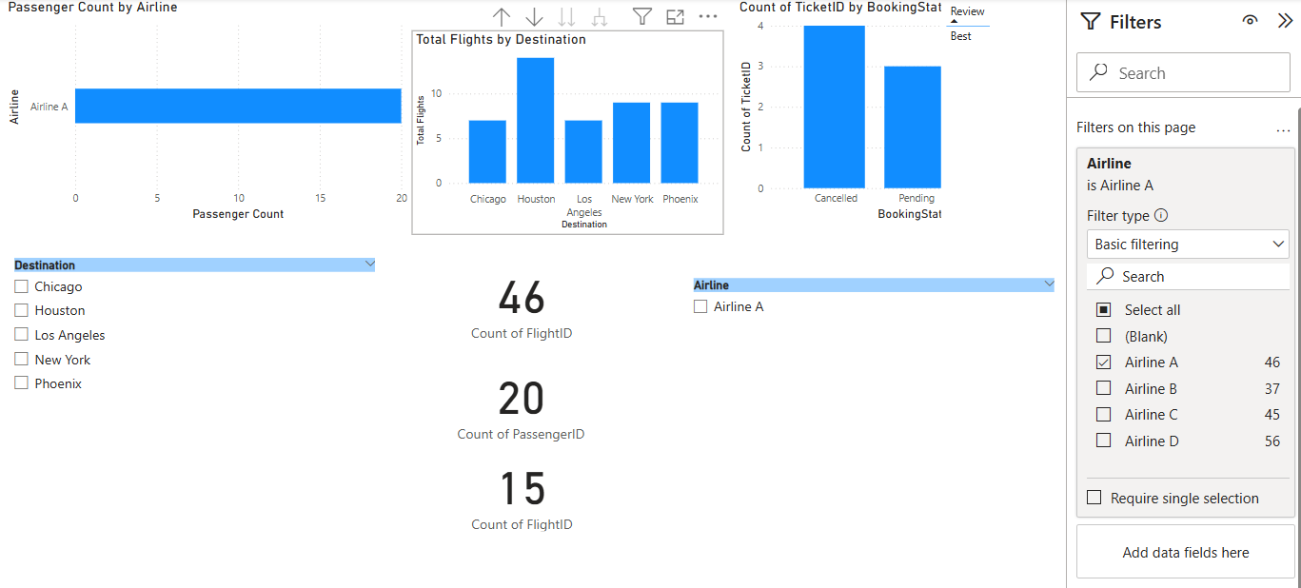

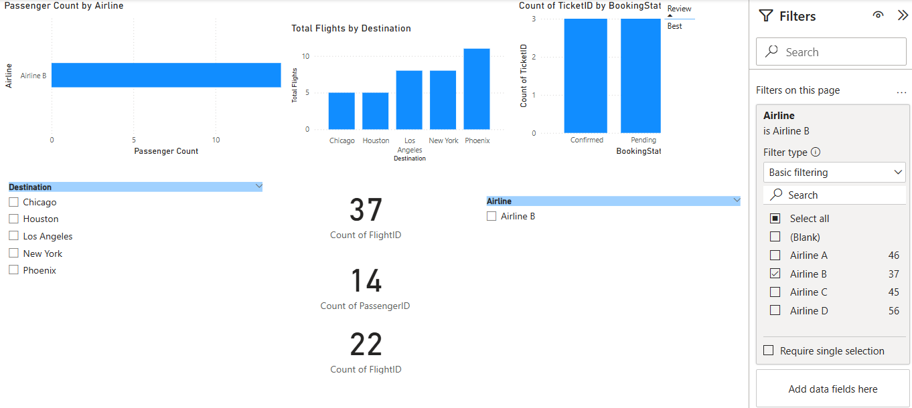

* Go to filter pane – drag Airline from flight_information—select the specific Airline(here I select Airline A and Airline B).

**Task 6:**

**comprehensive dashboard**

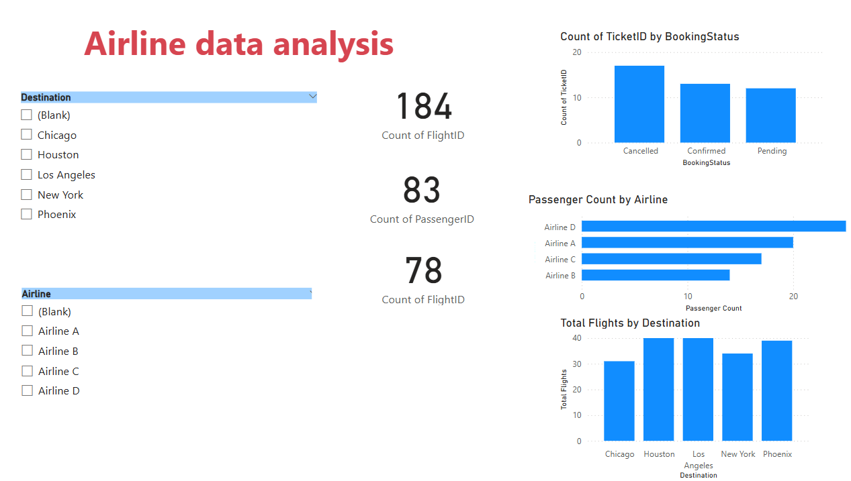

* Insert all the chart or card whatever is best for the visualization.
* Add text book to put Airline data analysis.
* The above rest of the data I got it from previous task’s reference.
* Once I align the visualization and key insights from the data we are ready to use Power BI service.

**Row-Level Security (RLS)**

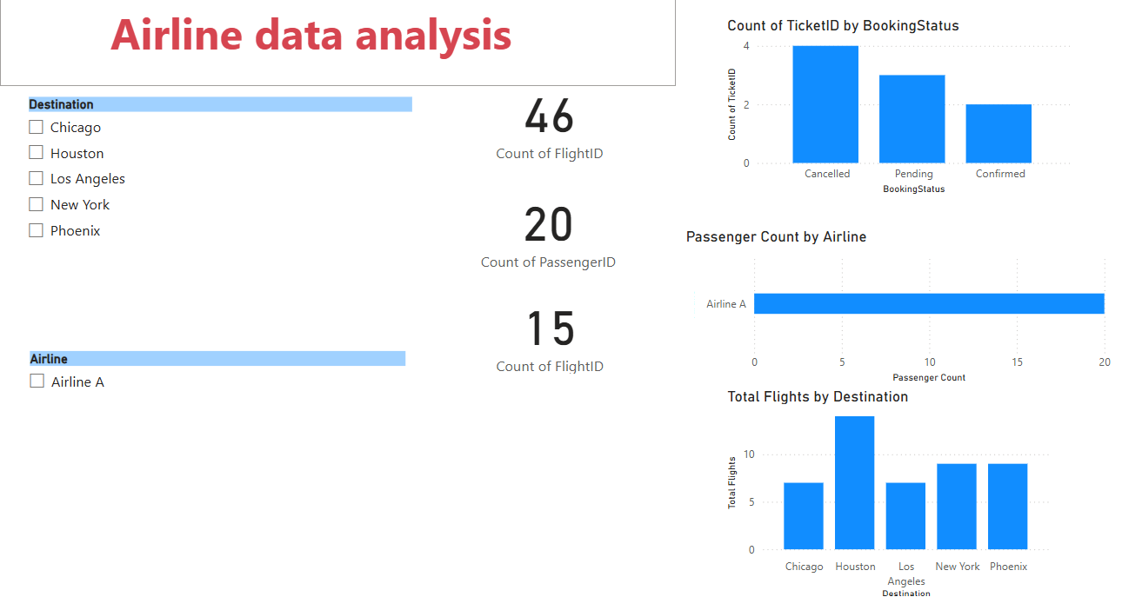

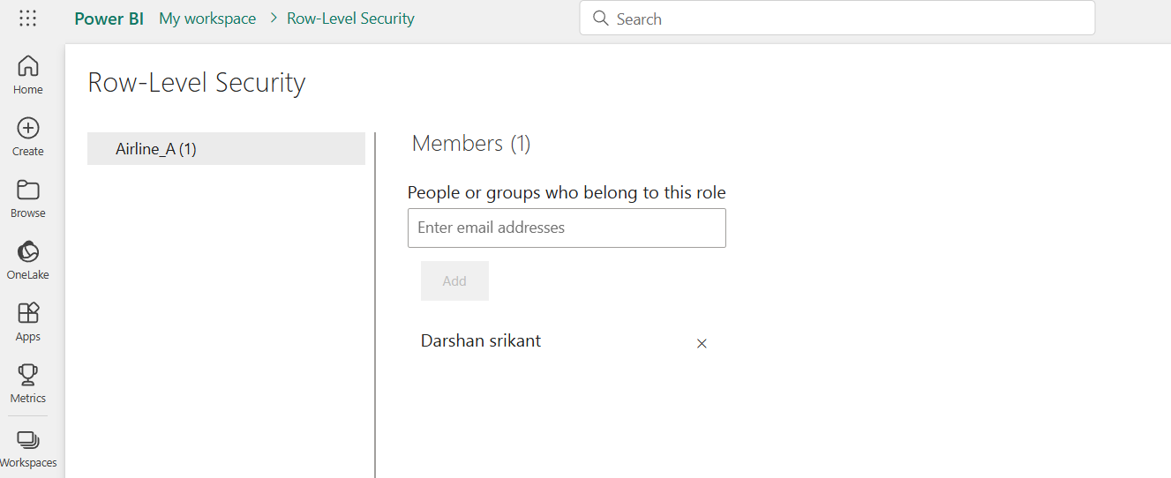

* Go to modeling – manage roles—create—name it as Airline A—and in values Airline A—go to view as roles—select Airline A.
* Publish the report to power bi service—click publish on home tab—on power bi service select the dataset you published—click security—assigh username or email.

**schedule refresh**

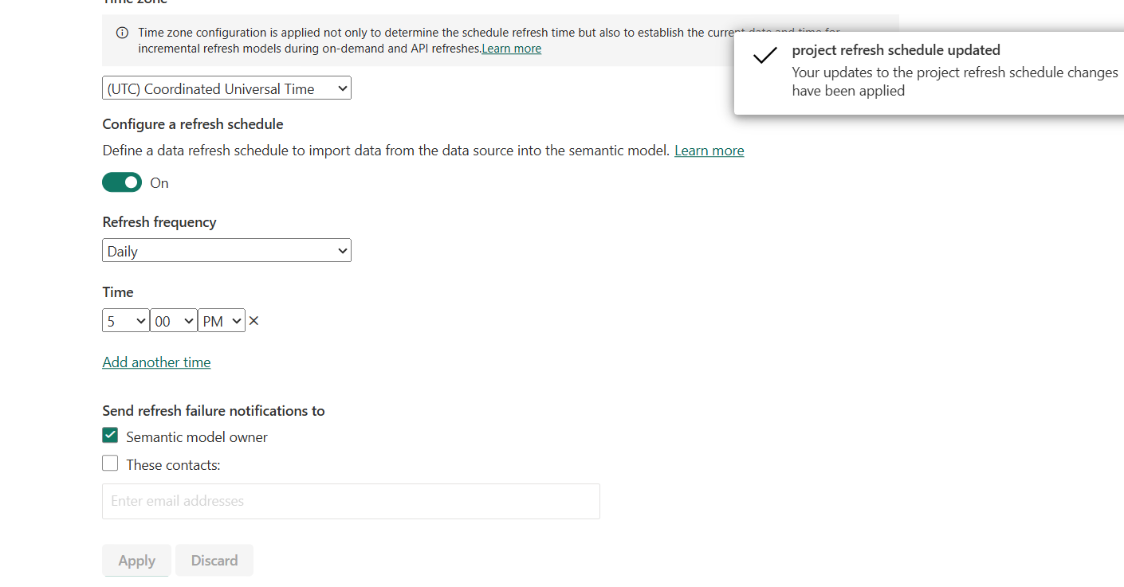

* Go to power bi service—in workspace select your dataset—click on more options above the dataset—choose settings—go to refresh—enable the configure a refresh schedule—set refresh frequency to daily—set time to 5:00 pm—click apply.